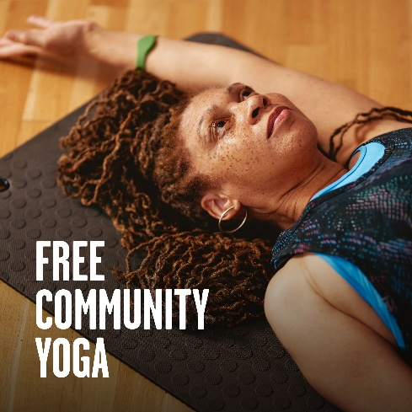
Better – FREE Yoga Classes
Join us every Tuesday morning for FREE Yoga Classes at South Bookham SPACE, delivered as part of Better’s Active Communities Programme.

The FREE Yoga classes are suitable for beginners and all levels, so no previous Yoga experience is required. Yoga mats and all equipment are provided, although you are welcome to bring your own mat if you prefer.

Choose from two FREE Yoga sessions:
- Every Tuesday, 9:00 – 10:00am – FREE Yoga
- Every Tuesday, 10:00 – 11:00am – FREE Yoga

📍 South Bookham SPACE, Dorking Road, Great Bookham, Leatherhead, Surrey KT23 4PB

Please note that you must create a FREE account and book each week. Each class is FREE.

Please click this link to book:
https://bookings.better.org.uk/location/leatherhead-leisure-centre/community-programmes/

The Yoga classes are part of Better’s Active Communities Programme, which has been set up to engage Mole Valley’s residents in low cost and free physical activity sessions across the district.

Better is the customer facing brand of Charitable Social Enterprise GLL, who operate Leatherhead Leisure Centre, Dorking Sports Centre and the Active Communities Programme in direct partnership with Mole Valley District Council.

You can find out more on the Active Communities Programme by visiting:
https://www.better.org.uk/leisure-centre/mole-valley/communities

